TL;DR
This Slackbot allows you to deploy two secure and cost-efficient agentic workflows on private modal infrastructure, without sharing data to third parties or exposing secrets to the agent.
- RAG agent — automatically indexes files and zipped folders uploaded through Slack, then answers your questions using a local LLM. Your documents never leave the GPU.
- ML agent — a Claude agent that trains and runs HuggingFace models on a GPU sandbox, without ever being exposed to your API keys.
Thanks to Modal GPU snapshots there is no idle compute costs. Tagging the bot cold starts within ~12 seconds. First deploy the model loads once (~4 min), then weights are checkpointed to CPU RAM. Every subsequent cold start restores from the snapshot and moves weights back to GPU in ~1 second.
- Why This Exists
- Features
- Architecture
- Setup
- Demo
  - RAG: Wikipedia
  - ML Training
  - Debugging
- Credits

Why This Exists
Basically, proprietary models are powerful generalists but expensive. Open-weight models are more accurate within their training domain and cheaper to run. This repo experiments with mixing both types into the same workflows to get secure, cost-efficient results.
The first workflow is an automated RAG pipeline that lets any user in a Slack workspace tag the bot to upload files and ask questions against those documents. It's completely private: document embedding, the vector database, and the LLM all run on Modal infrastructure. This also means you're not paying for idle compute. After 2 minutes of inactivity, the GPU shuts down, and spins back up quickly when tagged again, saving hundreds of dollars a month compared to renting a persistent GPU.
The second workflow uses GPU sandboxes to securely run a Claude agent with access to Hugging Face, letting you "vibe-tune" or "vibe-infer" any available model on any dataset and run your own experiments. The environment isn't attached to your file system, and your secrets are proxied into the sandbox, so the agent couldn't leak them if it tried.
It demonstrates how proprietary LLMs can use fine-tuned models as tools, processing data more accurately and cost-efficiently than they could otherwise. The example below shows a media processing task that would be out of reach for an LLM alone, since some data types fall outside what they're trained to handle.

Features

Slack Bot
Works in DMs (via the Slack Assistant protocol) and in channels (via @mentions). Upload files, ask questions, train models — all from Slack.

RAG Agent — Local LLM on GPU
A fully local RAG pipeline running Qwen3-14B-AWQ (4-bit AWQ) on an A10G GPU via vLLM. No external API calls for inference. Documents are indexed with ChromaDB and queried through a LlamaIndex ReAct agent with three tools:
- search_documents — semantic search over indexed documents using BGE-large embeddings
- execute_python — runs Python code for data analysis, chart generation, file processing (pandas, matplotlib, openpyxl pre-installed)
- list_documents — lists uploaded files so the agent can confirm paths before accessing them
Supports PDF, DOCX, CSV, Excel, and plain text. Indexing is incremental and only changed files are re-processed.

ML Training Agent — Claude on GPU
A Claude Agent SDK instance running on an A10 GPU sandbox. Writes and executes training code, installs packages, and trains HuggingFace models. The sandbox never sees the Anthropic API key — requests go through a proxy that swaps in the real key.
Training metrics sync to a Trackio dashboard on HuggingFace Spaces every ~30 seconds.

Slack Commands
Message | What happens
Any text | RAG agent answers using indexed documents
hf: <prompt> | Routes to the ML training agent
sources | Lists all uploaded files with sizes
reindex | Incremental re-index of documents
reindex --force | Full rebuild of the document index
status | Index stats (source count, chunk count)
clear | Wipes index, output files, and conversation history
remove <filename> | Deletes a file from the volume
Share/upload files | Downloads to volume, auto-triggers reindex

Architecture
Everything deploys as a single Modal app.
The Slack bot is a FastAPI + slack-bolt server that stays warm and routes messages. Plain text and file uploads go to the RAG agent. Messages prefixed with hf: go to the ML training agent.
The RAG agent runs as a Modal class on an A10G GPU. vLLM serves Qwen3-14B-AWQ (4-bit AWQ, ~8GB VRAM), ChromaDB stores embeddings, and a LlamaIndex ReAct agent orchestrates search and code execution. Documents never leave this container. GPU memory snapshots reduce cold starts to ~12 seconds: on first deploy the model loads into VRAM (~2 min), warms up, then offloads weights to CPU RAM via vLLM’s sleep mode before the snapshot is taken. Subsequent cold starts restore from the snapshot and move weights back to GPU in ~1 second.
The ML sandbox runs on an A10 GPU. Each request launches a Claude Agent SDK session that can write code, install packages, and train models. It talks to the Anthropic API through a proxy container that intercepts requests and swaps the sandbox’s fake key for the real one. The sandbox never sees your Anthropic API key.
The Trackio syncer polls a shared volume for metric databases and pushes updates to a HuggingFace Space dashboard.
Two volumes provide persistence: sandbox-rag holds documents, the vector store, and conversation history. sandbox-data holds model caches, training checkpoints, and session state.

Setup

1. Clone and install
git clone https://github.com/DeanAvI/modal-sandbox.git
cd modal-sandbox
pip install modal
modal setup

2. Create a Slack app
Use the included app manifest — it has all the required scopes and events pre-configured:
- Go to api.slack.com/apps and click Create New App → From a manifest
- Select your workspace, paste the contents of slack-manifest.yaml, and click Create
- Under OAuth & Permissions, click Install to Workspace and authorize
- Copy the Bot User OAuth Token (xoxb-...) from OAuth & Permissions
- Copy the Signing Secret from Basic Information → App Credentials

3. Create Modal secrets
# Slack bot credentials
modal secret create slack-secret \
SLACK_BOT_TOKEN=xoxb-... \
SLACK_SIGNING_SECRET=...
# Anthropic API key (used by the proxy — never exposed to sandboxes)
modal secret create anthropic-secret ANTHROPIC_API_KEY=sk-ant-...
# HuggingFace token (for Trackio metric syncing)
modal secret create hf-secret HF_TOKEN=hf_...
# GitHub token (for ML agent repo access)
modal secret create github-secret GITHUB_TOKEN=ghp_...

4. Deploy
modal deploy agents/slackbot/app.py
This deploys the Slack bot, API proxy, and pre-builds both GPU sandbox images. Modal will print the app URL — set this as the Request URL in your Slack app’s Event Subscriptions settings (the bot listens on /).

5. Upload documents (optional)
Share files directly in Slack by uploading in a channel (drag and drop, then @rag_bot to index them) or in a DM, or bulk upload via script:

Demo

RAG: Wikipedia
The Simple English Wikipedia dump is a clean benchmark: ~250,000 articles covering every topic, totaling around 1 GB compressed (~4 GB extracted). Too much for any context window, but exactly the kind of broad knowledge base where semantic search shines.
Upload the zip to the bot in Slack — it extracts and indexes the articles automatically.
How indexing works: The pipeline runs in three phases:
- Scan — compares each file’s mtime and size against a manifest to find only new or changed files. Already-indexed content is skipped.
- Embed — files are distributed across 8 parallel workers on A10G GPUs, with up to 4 workers sharing each GPU concurrently (@modal.concurrent(max_inputs=4)). Each worker runs a TEI embedding server as a sidecar subprocess, parses files, splits text into 512-token chunks with 64-token overlap using a sentence-aware splitter, embeds each chunk with BGE-base-en-v1.5, and upserts to its own ChromaDB shard.
- Finalize — worker manifests are merged into a single manifest.json, and ChromaDB shards are consolidated. The RAG agent reloads the index.
The full zip is 157 MB (551 MB uncompressed) containing ~242,000 articles. Indexing took 30 minutes across 8 parallel A10G workers.
Indexing progress message in Slack The bot reports indexing progress as it processes each batch of articles.
Then ask questions:
You: Plot a timeline of major space exploration milestones from 1957 to 2024.
Matplotlib chart of space exploration milestones The agent calls execute_python to extract dates and events from indexed articles, builds the chart with matplotlib, and uploads it to the thread.

ML Training
Prefix messages with hf: to route to the ML training agent:
You: hf: Train a model for categorizing multispectral satellite imagery
The agent asks clarifying questions about model choice, dataset, and HuggingFace username before writing any code:
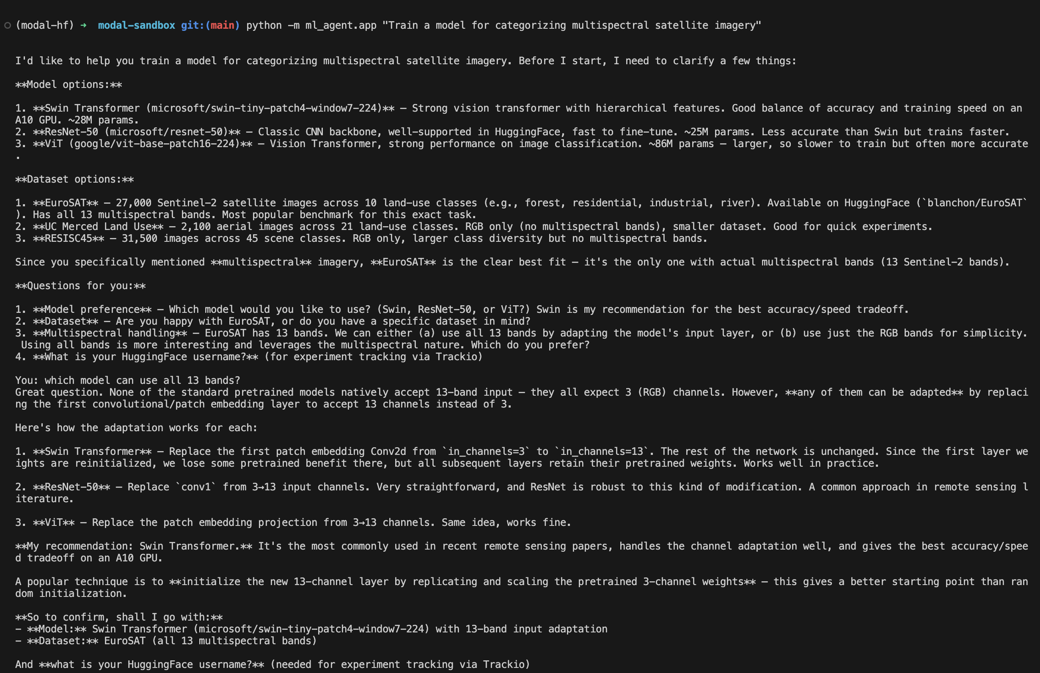 Agent suggests models and datasets with tradeoffs, then waits for confirmation.
Training metrics sync to a HuggingFace Space dashboard:
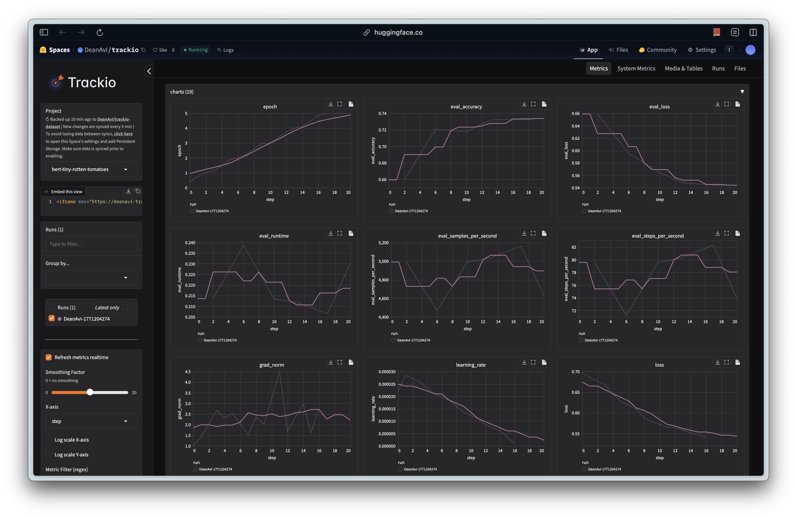 Metrics sync every ~30 seconds via Trackio.

Credits
- Qwen3-14B-AWQ — 4-bit AWQ quantization by Qwen, Alibaba Cloud.
- transformers skill — Originally by jimmc414, from Kosmos. Modified to integrate Trackio.
- hugging-face-trackio skill — From the official Hugging Face Skills repo. Licensed under Apache 2.0.
- Modal sandbox architecture — Based on the Claude Slack GIF Creator example from Modal’s docs.

